jk"Vªh; izkS|ksfxdh laLFkku & jk;iqj
NATIONAL INSTITUE OF TECHNOLOGY RAIPUR
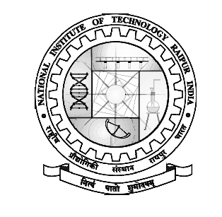
G.E. Road, Raipur – 492010 (C.G.)

No./NITRR/ Dean SW/3197 Dated: 19/05/2020

Health Awareness Lesson (HeAL)-3

Webinar on "Emotional and Mental Wellness Support of the students during the Covid"
May 29, 2020, Time: 3.00 PM to 5.00 PM
Convener: Dr. Prabhat Diwan (Dean SW)
Coordinator: Dr. Nitin Jain (Associate Dean SW)

Schedule of Webinar (29-05-2020)
Introduction of Webinar by Dr. P. Diwan (Dean SW, NIT Raipur)
(03.00 PM to 3.05 PM)

Inaugural Address by Dr. A. M. Rawani (Director, NIT Raipur)
(3.05 PM to 3.15 PM)
Session-1 by Dr. Ajit Varvandkar (Expert Counselor)
on
"The Good out of Covid"
(3.15 PM to 4.00 PM)
Session-2 by Dr. VikalpWasnik, MBBS, MD (Psychiatry)
on
"No Need to Panic during Covid"
(4.00 PM to 4.30 PM)
Session-3 by Dr. Hina Chawda (Counselor, NIT Raipur)
on
"Emotional Stability during Covid"
&
Valedictory of Webinar
(4.30 PM to 5.00 PM)

Dr. P Diwan
Dean SW, NIT Raipur

